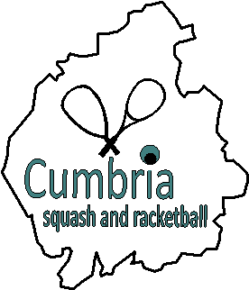

COUNTY JUNIORS – Coaching

The next County Junior Coaching session will be held at Wigton Squash Club on:

Saturday 27th November

Session times are:

Session | Age Group
10am - 12md | Under 11's
12md - 2pm | 11, 12 & 13 year-olds
2pm - 4pm | Over 13's

All standards welcome
£5 per session
Pre-booking is essential
Please pre-pay by bank transfer:
(Barclays, Cumbria Squash, 20-18-47, 20026689)

To book, email Chris Lilley (chris356lilley@btinternet.com):

- Name
- DOB
- Club

County Sponsor

